How to Survive Middle School


(Before Picture)

How to Survive
Swansboro Middle School

Congratulations, you are about to become a middle school student! You are probably excited and a bit scared. This is understandable and expected.

Hopefully this guide will make your transition to Swansboro a little bit easier. This guide will not answer all of your questions, so please ask questions when you think of them.

We are excited to welcome you to Swansboro Middle. Enjoy your summer and come to us in the fall ready to learn and enjoy middle school.



Hallway Rules

All 6th graders are on a separate 6th grade campus. The majority of your classes will be in two buildings on the 6th grade campus. You will have to travel to the main campus for encores, lunch, library, and main office. Follow these simple rules, and you will be able to get to class on time and without any problems.

- Talk to your friends during lunch and not in the hallway.
- Use the restroom during class changes. (It is possible if you focus and don’t talk to friends)
- Don’t run
- Be considerate when going to your locker. Understand that other students have a locker to the left, right, top or bottom. Please don’t take too long and don’t leave your items on the floor in the hallway
- Be considerate and watch your noise level…other classes may still be learning.

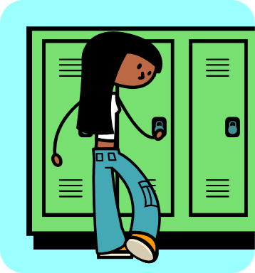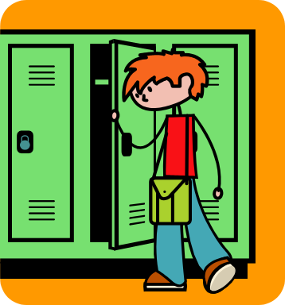
Locker Worries

The thought of dealing with a locker is on the mind of just about every new middle school student.

Why do we have lockers?
Your locker is your space to keep your books, jacket, bookbags and personal items so you don’t have to carry them everywhere. Bookbags are not allowed in the classrooms. Keep your locker neat and organized and it will make your life at middle school much easier. Your homebase teacher will assign you a locker after you pay your school fees. Please understand that while your locker is yours for the year, it is still the school’s property and must be treated with respect.

What about the locks?
Your homebase teacher will tell you the combination to your lock. The combination will have 3 numbers. Here’s how it works:

- Start at 0
- Turn to the right to the first number in your combination
- Turn to the left to the second number in your combination (you must pass the first number)
- Turn to the right to the last number in your combination
- Viola! Your locker is now open.



Tip: Practice using a lock over the summer!

Come to School! Be on Time!

One of the most important ways to ensure success at Swansboro Middle is to come to school. It is difficult to learn when you are not in class. If you are absent, bring a note from your parent/doctor for your absence to be marked either excused or unexcused. Students who are absent are responsible for making up any missed work. You will be given ample time to complete your assignments.

Tardiness can also be a problem for students. Students must be in class ready to learn by 7:20. This means that students need to have eaten breakfast (if they eat breakfast in the cafeteria), gone to their locker, and be in their seat by 7:20. During the open house in August parents can visit with the bus drivers to see what time the bus will come by their house.

Car riders can be dropped off in front of the 6th grade building.

If you arrive after 7:20 you need to check-in at the main office to receive a pass to class.
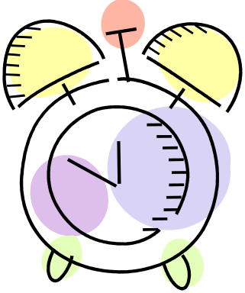

Elementary vs. Middle School

*Library- You’re probably used to going to the library as a class. Here in middle school, you will visit the library once as a large class as an introduction to the library. After that, you will need to ask your teacher to go. At the beginning of the year, you will learn the best times to visit the library.

*PE (Physical Education)- Instead of recess, you will have one semester of PE. The class will meet everyday. Don’t panic, but you will need to dress out for PE. This means, you need to bring an extra set of clothing to wear for PE class. Appropriate clothing are shorts and a t-shirt, which can be white, gray, or navy with no writing. Tennis shoes are a must! If you don’t dress out, you will lose points.

*Lunch- The same food you are used you will continue to see. You will receive a Student ID tag that you will scan in the cafeteria and library. You will sit at the designated table with your class.

* Small Changes- The life of a middle schooler is very busy. We do not have a snack time, keep water bottles in the class, or have recess. Instead of recess you will have physical activity time during your lunch period.

*Personal Responsibility- Now that you are a middle schooler, we expect you to be able to walk from one class to another without a teacher walking you. This means, you are responsible for walking to encores and from one teacher’s room to another when the bell rings. Teachers are in the hallways to offer assistance and monitor the students, but as a middle schooler you are given more freedom and responsibility.

Dress Code

The way you dress reflects the kind of person you are. It is generally accepted that cleanliness, good grooming, and appropriate dress helps reduce distraction, promote health, and provide a productive learning environment. Clothing that is not permissible includes, but is not limited to:
- Any clothing that advertises drugs, alcohol, or inappropriate language.
- Garments such as see through clothing, tank tops, halter tops, bathing suit tops, low cut blouses, spaghetti straps, tops supported by one or no straps, tight fitting clothing, or clothing that exposes the midriff or undergarments.
- Shorts and skirts are allowed, but must be no shorter than 3 inches above the knee. Tights and leggings are allowed, but the outer garment must be no shorter than 3 inches above the knee.
- Headgear such as caps, hoods, sweatbands, scarves, sunglasses, bandanas are not allowed.
- Any clothing or accessory that is gang affiliated is not allowed.
- Footwear not designed for public use, such as slippers or house shoes may not be worn to school.
- Pants and shorts must be secured above the waist so that undergarments are not exposed.
- Chains and spiked jewelry are not allowed.
- Clothing designed to draw undue attention or make the wearer conspicuous are not allowed.

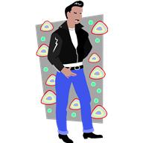
Teachers, teachers, everywhere!

One of the biggest differences between elementary and middle school is that instead of one classroom teacher, you will have several. You will switch classes throughout the day, instead of staying in one room.

Each day you will have 8 classes. These classes include, Language Arts, Math, Social Studies, Science, and two Encores (PE, Art, Music, or Computers).

You will have a team of teachers and there are three teams in 6th grade. Each team has its own locker schedule to help keep the hallways from being too crowded (remember to follow your team’s schedule). Remember that even though you may not have a particular teacher, he/she is still an adult and you may ask that teacher for help. You need to show respect to all adults.

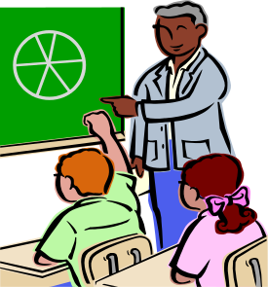

I have a what?!...A Schedule
A note about Encores: The only decision you have to make is do you want to play in the band or orchestra. If yes, then your other two encores will be PE and computers. If no, then you will take four encores, PE, computers, Art, and Music.
Here is what your schedule will look like (notice it has 2 semesters)

I Just Know I’m Going to Get Lost
Yes you may be confused about where to go the first couple of days. We promise that teachers will be in the hallways helping students go to their next class. If you do get lost, don’t panic! You can ask any adult where to go. But, here is a map of the school so you can begin to learn where classes are located.
OMG…You are Organized!
Students who are organized are successful students in and out of the classroom. This means you do the following:

- You need only one 3-inch binder. You will keep all class materials in this one binder so you will always have what you need with you at all times.
- Follow all teacher directions on filing away necessary papers in your binder in the right section.
- Turn in assignments on time! This will help you keep your grades up and shows the teacher you care about your academics.
- If you are absent, the day you return you ask every teacher for your make-up work.
- Make sure you copy your homework correctly in your planner. When you complete the work, check it off!
- Show your homework in your planner nightly to your parents.

Healthy Homework Habits
As a 6th grader, you will have homework almost every day! It is important that you learn how to study and do your work without being distracted so that you can do your best! Follow these tips when you are working:
- When you get home from school, do your homework right away. Plan playtime for when you finish your work (as a reward).
- Find a place in your home that is quiet and free of distractions. You want to choose a place where you can concentrate on doing your best!
- Make sure there is plenty of light, that you have enough pens/pencils/paper at your study area, and you have a comfortable chair to sit in (NOT your bed!).
- Ask for help when you don’t know how to do something. Write questions down so you can remember to ask the teacher the next day. Don’t give up or not do an assignment just because it is confusing.
- WRITE YOUR HOMEWORK IN A PLANNER EVERY SIGNLE DAY!!!! This way, you can never say, “I forgot!”

Bully Busters
Many new 6th grade students say they are afraid of being bullied by older students. At Swansboro Middle, bullying is NOT TOLERATED. We want all our students to feel safe and happy at school.
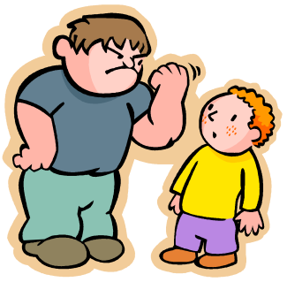
Did you know that most bullies pick on students because they want to feel powerful or in control? Instead of being respected, bullies become less popular because they hurt other’s feelings.
Before arriving at Swansboro, be sure to practice being friendly, kind, and respectful to everyone. If you ever feel like you are being bullied, here is a list of things you can try to do:

- Tell an adult you trust about the bullying.
- Try to ignore the bully and walk away from them without paying them any attention. If the bully does not get any reaction from you, they are less likely to keep bullying you!
- If the bully is picking on someone you know, stand up for the other person and tell the bully they are not cool.
Getting Along
At Swansboro you may not be on the same team as your best friend. That is okay. Middle school is a chance to make new friends. Challenge yourself to speak to someone new every day. Sometimes, we all get mad- even at our best friends. It is normal to disagree with others. However, it is important to try and work out your differences in a mature way…after all, you are now in middle school and teachers expect you to try solving some of your own problems.
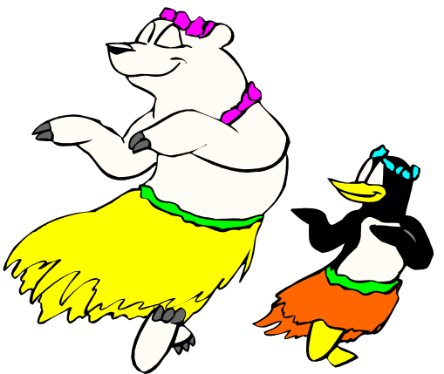
Next time you are fighting with a friend, practice these tips:
- Be clear and direct about what you want. Don’t spend your time blaming each other—look for a solution, instead.
- Pay attention to body language—does your facial expression and body gestures match what you are saying?
- Be a good listener. Don’t interrupt, and try repeating what the other person said.
- Don’t yell or scream…it only makes you and your friend more upset.
Get Involved
Even though 6th graders are not allowed to play sports, there are still several opportunities for you to get involved and show your Pirate Pride.

Odyssey of the Mind
Battle of the Books
Student Council Association
Yearbook
Academic Derby
Girls on Track
Rachel’s Challenge
School Musical
Relay for Life

 Go Pirates!

 Frequently Asked Questions

Q: Have you ever been lost?
A: No. At the beginning of the year when you are still learning where your classes are the teachers really help show us where to go.

Q: Do you have assigned seats in the cafeteria?
A: We have to sit at a table with our class but we are allowed to sit anywhere at that table.

Q: Will I see the older kids a lot?
A: No, the 6th grade campus is separate from the rest of the school. The only places you will see older students is when you walk to the main campus for lunch and encores. You will be on the bus with the 7th and 8th graders as well.

Q: What do I do if I forget my locker combination?
A: Your homebase teacher keeps a copy of the locker combination so she/he can help you.

Q: Am I allowed to decorate my locker?
A: Yes, just remember to be respectful to your locker. Anything you put up must come down at the end of the year. No stickers!



(After Picture ☺ )

