SBMS Check-in Check-Out (CICO) Daily Behavior Report Card

NAME: _____________________________________________________ DATE:________________
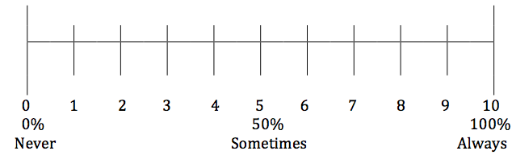
Teachers, using the above scale, please mark a score that best reflects student performance on each target behavior during your class period and initial.
Behavior Goals  Period | Target Behavior 1:  Be Responsible  Examples: Prepared for class, on time | Target Behavior 2:  Be Respectful  Examples: Acceptable behavior, appropriate communication | Target Behavior 3:  Be Productive  Examples: On-task, completed necessary work | T.I.
Period 1 | 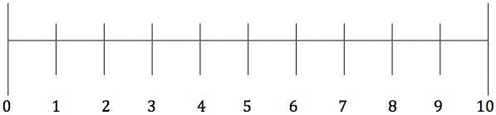
Period 2
Period 3
Period 4
Period 5
Period 6
Period 7
Advisory
(Fridays)
Incentive Box:
Points Earned:
Point Goal:
I Met My Goal

I Did Not Meet My Goal

Student Signature____________________________________ Teacher Signature___________________________________

